**MST 1102- Introduction to Statistics Practice 1**

**(Last Name, First Name): ________________________________________________________**

**Grouped Frequency Distribution**

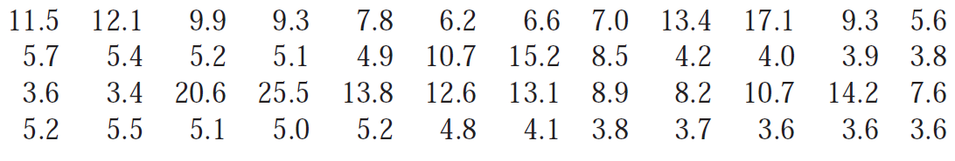Corrosion of reinforcing steel is a serious problem in concrete structures located in environments affected by severe weather conditions. For this reason, researchers have been investigating the use of reinforcing bars made of composite material. One study was carried out to develop guidelines for bonding glass-fiber-reinforced plastic rebars to concrete (“Design Recommendations for Bond of GFRP Rebars to Concrete,” *J. of Structural Engr.,* 1996: 247–254). Consider the following 48 observations on measured bond strength:

Using the $2^{k}$ rule to determine the number of classes, construct the grouped frequency distribution for the data.

**[Headings**: **Bond strength (class limits), boundaries, midpoint, tally, frequency]**

**General Rules for determining class limits**

1. If the data values are whole numbers, the limits would be whole numbers with a difference of 1 for the upper class limit of the current class and the lower class limit of the next class. This is equivalent to subtracting 0.5 from the lower class limit and adding 0.5 to the upper class limit.

Example: Classes: $11-20, 21-30, 31-40$

Boundaries: $10.5-20.5, 20.5-30.5, 30.5-40.5$

1. If the data values are to one decimal place, the limits would be to one decimal place with a difference of 0.1 for the upper class limit of the current class and the lower class limit of the next class. This is equivalent to subtracting 0.05 from the lower class limit and adding 0.05 to the upper class limit.

Example: Classes: $20.6-33.4, 33.5-40.9, 41.0-48.4$

Boundaries: $20.55-33.45, 33.45-40.95, 40.95-48.45$

1. If the data values are to two decimal places, the limits would be to two decimal places with a difference of 0.01 for the upper class limit of the current class and the lower class limit of the next class. This is equivalent to subtracting 0.005 from the lower class limit and adding 0.05 to the upper class limit and so on and so forth for different number of decimal places.

**SPSS: Defining Variables, Entering Data, Missing Values, Calculated Fields**

Students from MST1102 class were asked to participate in a simple experiment. Firstly their pulse rates were recorded. They were then asked to run in place for one minute. Then the pulse rates were recorded again. **Table 1.2** contains the pulse rates and other physiological and lifestyle data. A description of some variables is given in **Table 1.1**.

|  |  |
| --- | --- |
| **Variable** | **Description** |
| Height | Height (cm) |
| Weight | Weight (kg) |
| Age | Age (years) |
| Gender | Sex (1 = male, 2 = female) |
| Smokes | Smoker? (1=yes, 2=no) |
| Alcohol | Regular drinker? (1=yes, 2=no) |
| Exercise | Frequency of exercise (1=high, 2=moderate, 3 = low) |
| Pulse1 | First pulse measurement (rate per minute) |
| Pulse2 | Second pulse measurement (rate per minute) |

**Table 1.1**

|  |  |  |  |  |  |  |  |  |
| --- | --- | --- | --- | --- | --- | --- | --- | --- |
| **Height** | **Weight** | **Age** | **Gender** | **Smokes** | **Alcohol** | **Exercise** | **Pulse1** | **Pulse2** |
| 173 | 57 | 18 | 2 | 2 | 1 | 2 | 86 | 150 |
| 179 | 58 | 19 | 2 | 2 | 2 | 2 | 82 | 176 |
| 167 | 62 | 18 | 2 | 1 | 1 | 1 | 96 | 107 |
| 195 | 84 | 18 | 1 | 2 | 2 | 1 | 71 | 132 |
| 173 | 64 | 18 | 2 | 2 | 1 | 3 | 90 | 141 |
| 184 | 74 |  | 1 | 1 | 1 | 3 | 78 | 96 |
| 162 | 57 | 20 | 2 | 1 | 2 | 2 | 68 | 98 |
|  | 55 | 18 | 2 | 2 |  | 2 | 71 | 102 |
| 164 | 56 | 19 | 2 | 2 | 1 | 1 | 68 | 150 |
| 168 | 60 | 23 | 1 | 2 | 1 | 2 | 88 | 125 |

**Table 1.2**

**Instructions:**

1. Open SPSS and go to the variable view.
2. Define the variables by using the names given in **Table 1.1**.
3. Set all the values to the appropriate number of decimal place(s) as shown in **Table 1.2**.
4. Write a label for each variable based on the data provided in **Table 1.1** above.
5. Assign values (codes) to the **appropriate** variables.
6. Assign the correct measure to each variable.
7. Go to data view and type (or copy and paste) the data in **Table 1.2**
8. Assign a missing value to empty spaces and declare the missing value in the variable view.
9. Insert a calculated field to determine the BMI of each participant.
10. Insert a calculated field to determine the **squared deviation** of the height of each participant.

Report any issue or query to [aarif.baksh@yahoo.com](mailto:aarif.baksh@yahoo.com)